FOR IMMEDIATE RELEASE – APRIL 18, 2017
Contact: GILLIAN JACKSON
Brookline Commission for the Arts
brooklinearts@gmail.com
ZVI A SESLING NAMED BROOKLINE POET LAUREATE
Brookline, MA – The Brookline Commission for the Arts (BCA), which coordinates the Brookline Poet Laureate Program, has selected Zvi A. Sesling as the Town of Brookline’s third poet laureate to serve from April 1, 2017, to March 31, 2020.
Sesling succeeds Jan Schreiber, whose term ended on March 31. The Brookline Poet Laureate Program, established by the Board of Selectmen in 2012, seeks to enhance Brookline’s cultural life, promote awareness and appreciation of poetry and the literary arts, and connect members of the community through poetry.
The poet laureate’s activities will focus on celebrating poetry in the town, educating citizens of all ages in the art and pleasures of poetry, and serving as a poet for significant town occasions and events.
Sesling, a former Brookline Selectman and town meeting member, is the author of two volumes of poetry, King of the Jungle and Fire Tongue, and two chapbooks, Across Stones of Bad Dreams and Love Poems from Hell, and has published poetry in more than 200 literary journals. Sesling also publishes the online poetry journal, Muddy River Poetry Review.
The members of the selection committee, Donna Hollenberg, John Plotz, Barbara Scotto, Michael Burstein, Dana Brigham, Sarathchandra Reddy and Jan Schreiber, met in March to review applications for the post, which pays a $2,000 per year honorarium and is sponsored by Brookline Booksmith.
“The Changing of the Bard,” an event to introduce Sesling to the Brookline community, will take place at Brookline Village Library, Hunneman Hall, on Thursday, May 11, from 7:00 to 8:30pm. Sesling will be joined at this free community event by Jan Schreiber and Judith Steinbergh, past Brookline poets laureate, to read the works of New England poets.
The BCA, made up of Brookline residents appointed by the town’s Board of Selectmen, funds a broad range of literary, musical, theatrical, video, educational, and arts projects that enhance the cultural life of Brookline. It is part of the Massachusetts Cultural Council’s Local Cultural Council program — the largest grassroots cultural funding network in the nation, supporting thousands of community-based projects annually in the arts, humanities, and sciences in 351 cities and towns in the Commonwealth.
For information on upcoming grantee events and on the BCA visit www.brooklinearts.org.
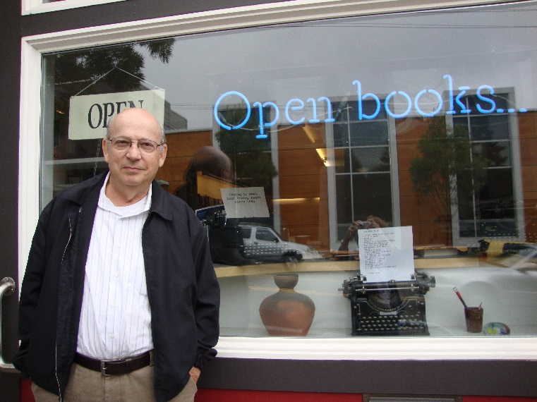
Brookline Poet Laureate, Zvi A Sesling

