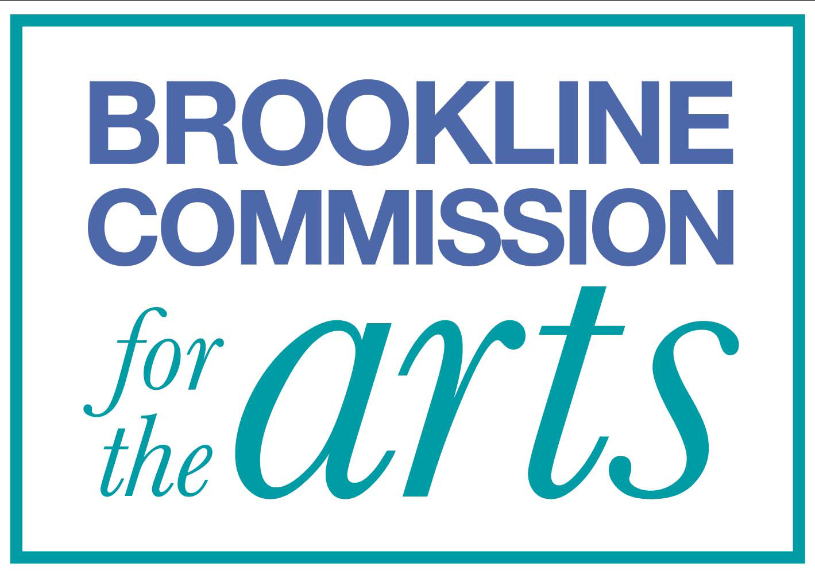
Town Hall Walls

An art exhibition program sponsored by the Brookline Commission for the Arts

GUIDELINES AND APPLICATION PROCEDURES

Please submit the following to be considered for the Town Hall Walls program:
1. Completed Town Hall Walls Application Form
2. 5 to 10 representative images*
3. A list of the images provided with title, medium, dimensions (HxWxD), year created, and whether the work is framed or matted
4. A résumé, artist statement, and/or brief description of your art experience
5. A self-addressed, stamped envelope with proper postage for return of materials (if applicable)

*Electronic images should be 300 dpi at maximum quality with 1024 pixels longest side. Each image should be labeled as follows: last name-first name_title (smith-john_sunrise.jpg). The images can be emailed as part of the proposal or burned to a CD, clearly labeled with your name and contact info. If you need assistance meeting these requirements, please contact the BCA for further help.

Please email all application materials to brooklinearts@gmail.com with subject line: "Town Hall Walls Application." Completed applications may also be mailed to Town Hall Walls, Brookline Commission for the Arts, 333 Washington Street, 6th Floor, Brookline, MA 02445.

Priority will be given to Brookline residents, individuals who work in Brookline, those who practice, e.g., have studio space, in Brookline, and those without prior THW participation. Projects with a strong connection to Brookline but without a direct Town affiliation may also be considered, subject to scheduling constraints.

The selection will be made by a working group of the Brookline Commission for the Arts which will consist of current members of the Commission, and may also include invited members of the community with expertise in the arts. Applicants will be notified of results by email.

The Committee will schedule each successful applicant for a four-month long exhibition in one of four spaces in Brookline Town Hall: Room 103, Room 111, the sixth-floor Hearing Room, and the first-floor display case (small 2D or 3D works). Exhibitions typically begin in February, June, and October, depending on availability of space. If certain dates present scheduling conflicts, please indicate these on your Application Form. Exhibiting artists will also be expected to attend a group reception, on a date (usually a Friday evening) to be mutually agreed upon by participating artists.

Individuals and organizations chosen for exhibition will be required to sign the "Insurance/Waiver, Release and Indemnification" provided by the Town of Brookline. Additionally, all work on view must also adhere to the "Town of Brookline Policy on Displays and Exhibits at Town-Owned Properties."

Please review these documents, available on the BCA website, before submitting your proposal.

For further information or assistance, please visit www.brooklinearts.org, email brooklinearts@gmail.com, or phone 617-730-2135 to leave a message for Gillian Jackson, BCA Administrator.

