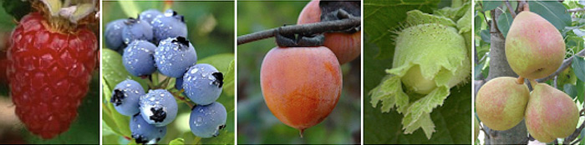

**Edible Perennial**

**Gardening and Landscaping**

***with Naturalist and Landscaper John Root***

Wednesday, May 21 at 6:30 PM

Brookline Public Library

361 Washington St.

Learn how to establish and maintain a variety of perennials,

including trees, shrubs, vines, canes, and herbaceous plants,

that yield abundant crops of delicious and nutritious food

throughout the growing season with minimal maintenance.

Free admission; all ages welcome.

This program is supported in part by a grant from the Brookline Commission for the Arts,

a local agency which is supported by the Massachusetts Cultural Council, a state agency.

full

www.johnroot.net